### *Royal Wootton Bassett Pétanque Club (RWBPC)*

### *Facebook: Royal Wootton Bassett Pétanque Club* [*http://www.rwbpc.co.uk*](http://www.rwbpc.co.uk)

Our winter sessions are just as busy as in the summer helping the colder months to pass very quickly as we continue playing all year. Club members enjoy the opportunity of both competitive and recreational play proving Petanque is an excellent past time for all ages, we have players from 7 years through to over 70+ years. Due to demand we have added a Thursday evening session.

***Competitions***

* **Internal Club competitions**

A new weekly ‘Pairs’ competition offered players a taste of playing to formal rules in a competitive environment. Designed to help teams go forward into the wider region for competitions – it worked as the September Club Melee was won by Brian Claridge in a very competitive field.

* **Local and Open Competitions**

The completion of the **Cotswold league** saw the RWB Royals team top Division 1 retaining the Cotswold Shield for another year. Success was also achieved for RWB Bees who topped Division 3. RWB Allsorts tried hard but this year were placed at the bottom of Division 1. Next spring will see a slightly rearranged Cotswold League with the possible move to two larger Divisions.

* **3-Ender Open Competition** held at Cricklade Petanque Club saw two RWBPC teams Alan and Lawence Bond and Colin and Marion Sweet take First and Second places out of 22 teams playing.
* **RWBPC Ladies** teams competed against Cricklade Ladies and took the victory once again.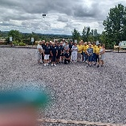
* **Bath Open -** RWBPC teams made it through to the Gold Section of this popular competition.
* **Tiger Trophies Cancer Research Open Competition – including fancy dress -**saw RWBPC Sue Slucock involved in the Silver section during her first competition. 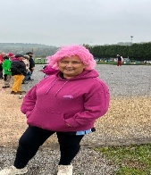 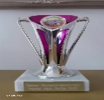 Mary and Rod Elliott won trophies in the Bronze Section with Colin and Marion Sweet winning trophies in the Pewter Section.

**Great Western Region Competitions**

* **Inter Regional Finals** - as part of the Great Western Region, RWB PC had 3 teams and two Team Managers involved in the largest gathering of Pétanque players - 1200 players - from 18 regions across the UK, including England Scotland, Wales. 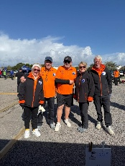Tough competition saw GWR maintain their positions in the Championship and Challenge divisions. GWR Juniors who entered for the first time did extremely well in being placed 3rd. RWBPC was represented by Nina Marchant in the Junior section.

* **GWR TRIPLES** held at Cricklade Petanque Club in early September saw RWBPC’s Mary Elliott win the Silver Section with players from Bath.
* **GWR Mixed Doubles** in late September saw 2 teams from RWBPC battle it out in the final of the Silver Section of the GWR Mixed Doubles. Colin Sweet and Marion Sweet won in a hard fought match.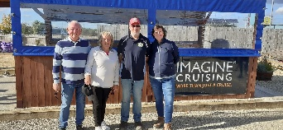
* **GWR Winter ‘Doubles’** started in later October and continues until early March. RWBPC is very well represented in having seven teams entered. Each team will be playing teams from across the GWR region e.g. Filton, Bath, Corsham, Biddlestone, Cricklade, etc.
* **National Competitions –** Two teams, RWB Royals and RWB Allsorts have started competing in the Euro Cup competition to represent England in December 2026.

**Social Activities**

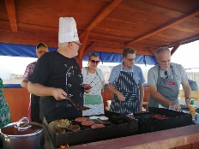Through 2025 we held a BBQ, a Chilli evening, a Coffee morning and our annual Dinner. This meant during 2025 we raised over £2500 for charities such as Alzheimer’s Research and Parkinson’s Disease, Macmillan Cancer Research. We continue support for charities in 2026 including the BrainsTrust.

***More info:*** [*AlanMcInnes1@outlook.com*](mailto:AlanMcInnes1@outlook.com) ***or*** [***Marionsweet4@aol.com***](mailto:Marionsweet4@aol.com)

Join usat any of our  **Open sessions Tuesdays 10am-12noon, Tuesday evenings 7pm to 9pm, Thursday evenings 7 pm-9 pm and Friday mornings 10 am -12 noon. New members always welcome so come along.**

***RWBPC Sponsored by Imagine Cruising.***